Mindfulness
Mindfulness is when one observes their thoughts and feelings without judgement. Through mindfulness individuals can improve emotional regulation and attention. Mindfulness can also be an effective strategy to work on executive functioning skills.

Areas that mindfulness can improve
Procrastination-Mindfulness can help you become more aware of your thoughts and explore the underlying reasons for procrastination. If you know why you procrastinate you can take steps to work on reducing engagement in procrastination.

Time management-Time can get away from many of us. Mindfulness can be helpful in becoming more present and aware of what is occurring now. Practice mindfulness to make it to appointments and turn in assignments on time.

Emotional regulation-Mindfulness can assist with exploring emotions and becoming more aware of your emotional response. Increased awareness and understanding of your emotions can lead to improved emotional regulation, which can assist you with activating your problem-solving skills. An emotionally distressed brain has a harder time thinking through how to solve a problem.

How to practice mindfulness
Check out Koru Mindfulness at Hokie Wellness to learn more about mindfulness and how to practice it.
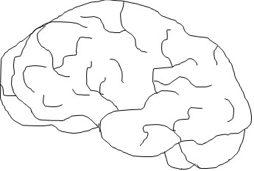 Image description: Drawing of a human brain.

