Reading Strategies

Review these strategies for additional support with reading.
- SQ3R-This acronym stands for Survey, Question, and the three r’s Read, Recite, and Review. The SQ3R method was originally developed by Francis Please Robinson, a professor at Ohio State University. Robinson used this method to help military personnel. This method will assist with increasing understanding of the material.

- KWL- This is an acronym for Know, Want, and Learn. It was created by Donna Ogle. KWL can be used for reading or as a study strategy for other subjects. When using KWL students are encouraged to think about what they already know about the material, what they want to know, and what they learned. The KWL method will assist with reflection, understanding, and recall of material.

- GIST- This acronym stands for Generating Interactions between Schemata and Text. Students think about who, what, when, where, why, and how when reading. Afterwards, take time to summarize in 15-20 words.
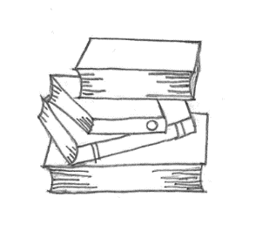 Image description: A set of four stacked books.

References:
Cook Counselling Center. “SQ3R Improving Reading Comprehension.” Virginia Polytechnic Institute and State University. https://ucc.vt.edu/academic_support/online_study_skills_workshops/SQ3R_improving_reading_comprehension.html.
TeacherVisionStaff. “Using “KWL” In Your Classroom Strategy. TeacherVision. https://www.teachervision.com/graphic-organizer/using-kwl-classroom.
Helmut. “The SQ3R Method of Studying-The Father of All Reading Methods is Alive and Kicking.” Remember Everything. https://remembereverything.org/the-sq3r-method-of-studying/.
Parks, Jaye. “GIST, A Summarizing Strategy for Any Content Area.” Smore. https://www.smore.com/9vm80-gist.

