The Pomodoro Technique and Executive Functioning
The Pomodoro Technique was developed by Francesco Cirillo in the late 1980s. Cirillo named the technique the Pomodoro Technique after the tomato shaped kitchen timer he used. Pomodoro is the Italian word for tomato. The Pomodoro Technique can be used as a study and time management strategy. It is a great way to improve academic and career performance by increasing productivity.
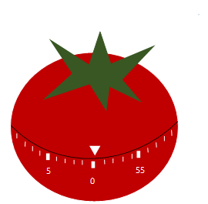Image description: kitchen timer shaped like a red tomato

Here’s how you do it…
Decide on a task
Set a timer for 25 minutes
Take a 5 minute break after the 25 minutes is up
Take a longer break of 15-30 minutes after every 4 pomodoros

Why it works for executive functioning...
- Promotes task initiation. Think about how quickly 25 minutes will go!
- The timer provides structure. You know how long to work, so you don’t lose track of time.
- You get a break! Your brain has a moment to relax and process the information you’ve been working on.
- You get a sense of how long it takes to complete a task, which can assist with planning out how much time to set aside.
- It’s also a great way to make a task more fun by challenging yourself to see if you can make it to the end of the 25 minutes.
Make it work for you and modify when needed. Set the timer for 10 minutes if having a hard time with task initiation or if motivated set it for longer than 25 minutes. Try it out a few times before giving up.

Reference:
Scroggs, Laura. “The Pomodoro Technique.” Todoist, https://todoist.com/productivity-methods/pomodoro-technique.

